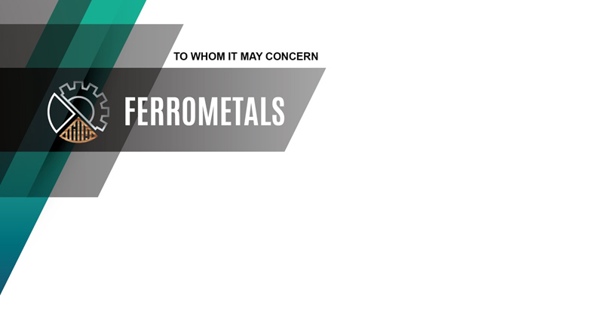

№155 dated 20/03/2023

Ferro metals UAB offers the manufacture and installation of polymer painting line according to the technical specification.

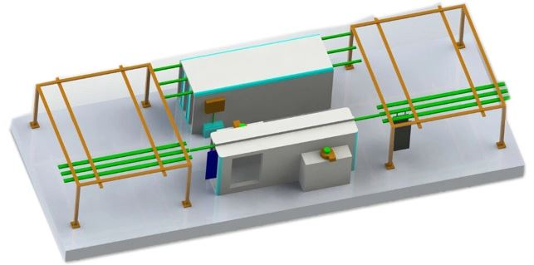

The line is available in ring and semi-ring versions. In the ring version there is the possibility workpieces to pass through the chambers, that improves the logistics for painted and unpainted parts due to constant loading/unloading points and moving directions, applicable for large batch continuous production. If there is a requirement for maximum compactness of the line, a semi-ring version is available where the chambers are of a dead-end design and the transport system involves a reciprocating moving of the workpieces between the chambers.

The line includes:

1. Polymerization chamber with an automated control system.

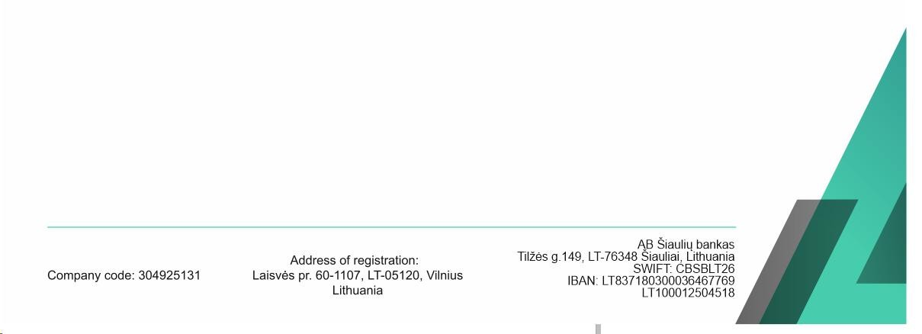 The construction of the chamber includes:

- insulated casing with galvanized steel sheet finishing on the inside;

- a thermoblock with stainless steel ribbed heating elements and a forced air circulation system with a special heat-resistant fan. The inner surface of the air duct is finished in stainless steel to prevent scale build-up and subsequent contamination of the products being painted;



- full-featured control unit with touch screen panel and user-friendly graphical interface for fully automatic operation (heating on - holding - heating off - forced purging (cooling) of switched off heating elements);

- sturdy hinges and chamber frame prevent the door from sagging and the casing from distorting;

- simple electrical circuitry using standard components ensures high maintainability;

- exploitable floor: the heating elements are located in the air ducts of the thermoblocks - outside the interior of the chamber, allowing, if necessary, to place products on the floor if they cannot be hung on special hinges;

- forced-air circulation system for uniform air mixing and temperature stabilization throughout the entire volume of the cooking chamber within a range of 5 °C;

- an exhaust hood to remove gaseous emissions when the chamber door is being opened at the end of the cycle.

2. The electrostatic powder chamber is equipped with a high-performance manual powder spraying unit and a system for the recovery of the unused powder.

The design of the chamber provides for:

- operator's presence inside the booth during the painting process (walk-in chamber);

- chamber walls made of transparent dielectric polymer;

- floor covered with galvanized sheet metal for easy removal of any powder residue;

- LED lighting of the working area;

- swing or sliding doors (optional);

- a recovery system designed to extract air from the spraying chamber, filter it, collect polymer powder that has not settled on the surface of the painted parts in a special hopper, in order to return it to the technological cycle. Two stages of cleaning are used: the first stage is a cyclone, the second stage is a cartridge polyester filter. The degree of air purification is up to 99.9%.



3. Conveying system based on upper hanging multi-strand rails and a set of roller hanger-carriages for workpiece fastening.

The chamber design provides for:

- high load-bearing capacity and docking accuracy due to the use of a high-strength rolled closed profile for guides - weight of a single workpiece up to 500 kg;

- easy manual movement of the carriages with the workpieces due to hinged hangers on the rolling bearings with heat-resistant graphite-filled grease;

- the path through the application chamber is located in the air lock to prevent powder accumulation on the surface of the hangers;

- modular demountable design allowing changes and additions to the configuration as needed to adapt to workpiece dimensions or process cycle, as well as easy installation.

Additional options:

Mechanized conveying system based on an electrically driven ring hanging multi-row conveyor.

Forced air-cooling section with separate transfer line and exhaust ventilation.





Состав базового комплекта линии полимерной окраски:

|  |  |
| --- | --- |
| № | Name of the equipment |
| 1 | **Chamber for applying powder polymer paint in an electrostatic field**  Chamber type feedthrough  Binding to the transport system top  Power options 380/50  Internal dimensions of the chamber, mm 8000 x 2000 x 3000  Equipped with a powder coating unit in an electrostatic field and a system for supplying clean air to the operator's helmet  Powder container capacity, kg 40  Total power, kW 8 |
| 2 | **Conveying system**  Conveyor type looped hanging reversible  Type of traction element traction plate chain with  traverses  Route type running I-beam  Step of load-handling traverses, mm 400 mm  Total load capacity, kg 1500  Drive power, kW 3  Movement speed, m/s 0 – 250  Track length, m 35 |
| 3 | **Polymerization chamber**  Chamber type feedthrough  Binding to the conveying system top  The total power of heating elements, kW 200  Operating mode automatic  Time to reach operating mode  at max. loading, min 40  Max. heating temperature, C ° 230  Power options 380/50  Voltage on heating elements, V 220  Number of thermoblocks, pcs 4  Internal dimensions of the chamber, mm 8000 x 3000 x 3000 |

The cost of the offered equipment is 43000 euros, VAT excluded.

The price may vary depending on the size and configuration.

Equipment delivery time: 60 days after receipt of prepayment.

Warranty: 12 months.

If you are interested in our offer - we are ready to send technical specialists to clarify details of supply.